Section 1: Application Summary
Name of Product | REGENETEN BioInductive Implant
Australian launch date | 2019/2020
Products used in (please select) | ✔ treatment
Contact details | Chris Padovan – Business Development Manager ANZ

Your details
Name | Chris Padovan | Position | Business Development Manager
Email | christopher.padovan@smith-nephew.com | Phone | +61 402 148 025
Name of Company | Smith & Nephew | ABN | 68000087507

Executive Summary: [200 words max.] NB Executive Summary must be suitable for use in Award promotion

The REGENETEN BioInductive Implant is a highly porous, highly aligned, highly purified collagen scaffold that is disrupting the current treatment pathways for Rotator Cuff Disease.

The implant is both an Inductive and Conductive scaffold that rapidly induces the growth of new tendon like tissue.

Section 2: Product Details
Describe the technology [300 words max.]

Regeneten is a highly porous, precisely oriented reconstituted collagen implant made from thoroughly purified, bovine type I collagen. It stimulates the body’s natural healing response to support new tendon growth and disrupt disease progression.

It has been clinically proven to reliably induce new tendon-like tissue and promote tendon healing.

The implant gradually absorbs within six months, leaving a layer of new tendon-like tissue to biologically augment the existing tendon.

The induction of a layer of new tendinous tissue on top of the tendon is intended to reduce micro-strains within the tendon and provide an optimized mechanical environment for tendon healing and inhibit or arrest, tear propagation.

The implant is inserted using a set of specifically designed arthroscopic instruments that require a minimal amount of time to be added to the surgeon’s current procedure.

What health problem is the technology addressing and how does it address the problem? [300 words max.]

Regenten is a technology that interjects in the progression of tendon disease.

Rotator cuff disease is a significantly debilitating condition, it is progressive and not reversible.

The current treatment pathway is to wait for the disease to progress to a stage that requires multiple surgeries to manage and repair the tendon. This treatment paradigm also incures a significant cost implication and burden to society.

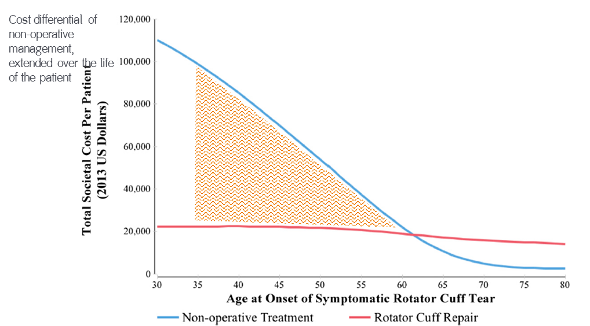

Regeneten is designed to stop progression of the disease at an earlier stage than traditional surgical intervention, whilst reducing rehabilitation times and overall cost of the burden of the disease to the community.

What other products are currently available to address this issue and how does this technology differ from and/or improve on existing technology? [300 words max.]
Medical Technology Association of Australia Limited ABN 61 129 334 354

There are no products currently available on the market within this space that enact the same biologic response and produce the same outcome as Regeneten.

There are other products on the market that are designed to assist in strain reduction to allow a repaired degenerative tendon to heal, however none of these products are absorbed or induce new tissue growth.

Regeneten is also the only implant that has a specifically designed arthroscopic delivery system to reduce insertion times and allow the surgeon to continue to perform the procedure arthroscopically.

Having regard to the consumer’s quality of life, does the product provide a balance between invasiveness and efficacy? [300 words max.]

The product is designed to be surgically inserted in a manner that is minimally invasive to the patient. It does not require any additional incisions than that of ‘normal’ arthroscopic shoulder surgery.

The post op protocol for use of this product is also the same as the surgery that would have been performed on the patient.

For those patients that would have typically undergone an acromioplasty or subacromial decompression as surgical intervention the post op protocol remains the same.

For patients that would typically have had a rotator cuff repair procedure performed as surgical intervention the post op protocol remains the same.

When interjecting early in the cycle of tendon disease progression, the Regeneten implant has been shown to reduce the amount of time required to return to work, return to driving whilst also reducing post-operative opiod use.

Include scientific evidence to support the claims. This may include published data, unpublished scientific data, results of clinical trials and/or patient feedback. Photographs may be submitted. Product samples will not be accepted.

• Bokor DJ, Sonnabend D, Deady L et al. “Evidence of healing of partial-thickness rotator cuff tears following arthroscopic augmentation with a collagen implant: a 2-year MRI follow-up.” MLTJ 2016

• Bokor DJ, Sonnabend D, Deady L et al. “Preliminary investigation of a biological augmentation of rotator cuff repairs using a collagen implant: a 2-year MRI follow-up.” MLTJ 2015

• Schlegel TF, Abrams JS, Bushnell BD, Brock JL, Ho CP. “Radiologic and clinical evaluation of a bioabsorbable collagen implant to treat partial-thickness tears: a prospective multicenter study.” J Shoulder Elbow Surg 2018

• Arnoczky SP, et al. “Histologic evaluation of biopsy specimens obtained after rotator cuff repair augmented with a highly porous collagen implant.” Arthroscopy 2017

• Thon SG, et al. “Evaluation of healing rates and safety with a bioinductive collagen patch for large and massive rotator cuff tears: 2-year safety and clinical outcomes.” Am J Sports Med 2019.

• McIntyre L, et al. “Patient-Reported Outcomes After Use of a Bioabsorbable Collagen Implant to Treat Partial and Full-Thickness Rotator Cuff Tears.” Arthroscopy 2019

Section 3: Declaration
I certify that the information provided in this application is accurate and that the company accepts the Rules of the Award. Representative/s of the company will participate in promotional activities relating to the Award.

Name: _ Position:

Signature of the CEO/Authorised Representative:

Date: / / _

Please send your application to MTAA Secretariat – Kerrin Rennie Award

CLOSING DATE: 26 JULY 2019

